Gambar yang wajib ada
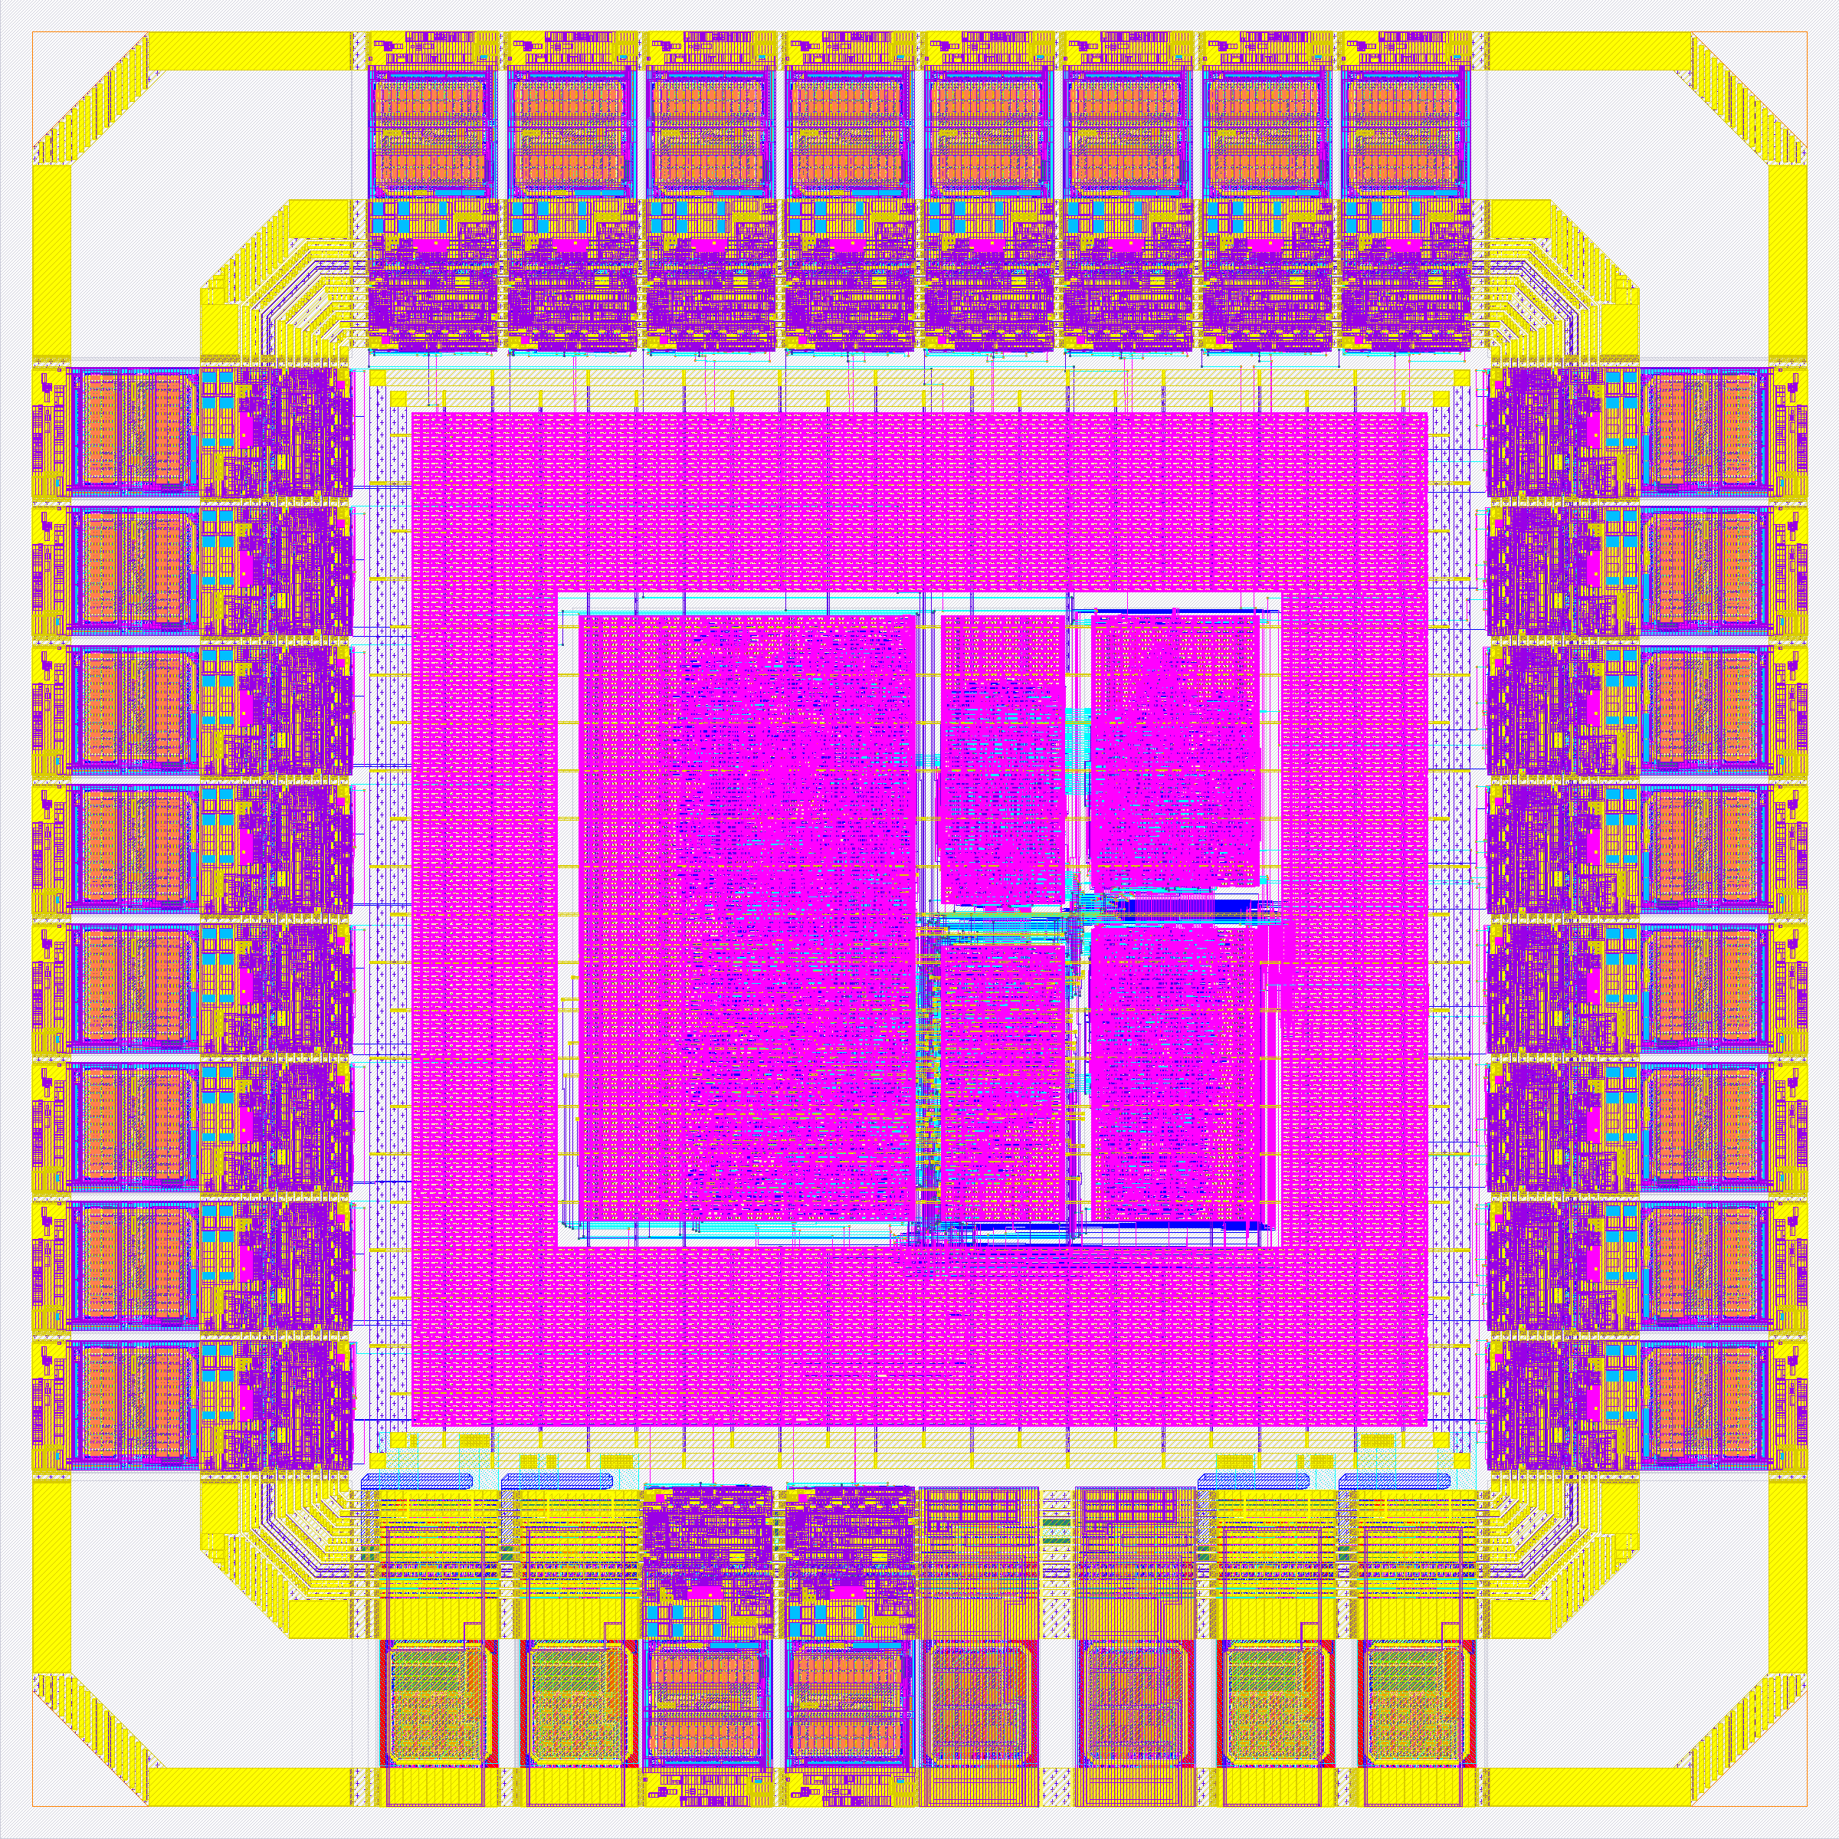
GAMBAR 1: DESAIN TATA LETAK
(LAYOUT DESIGN)
Die utuh stereo_slice_chip, 1.151 × 1.151 µm, sky130A

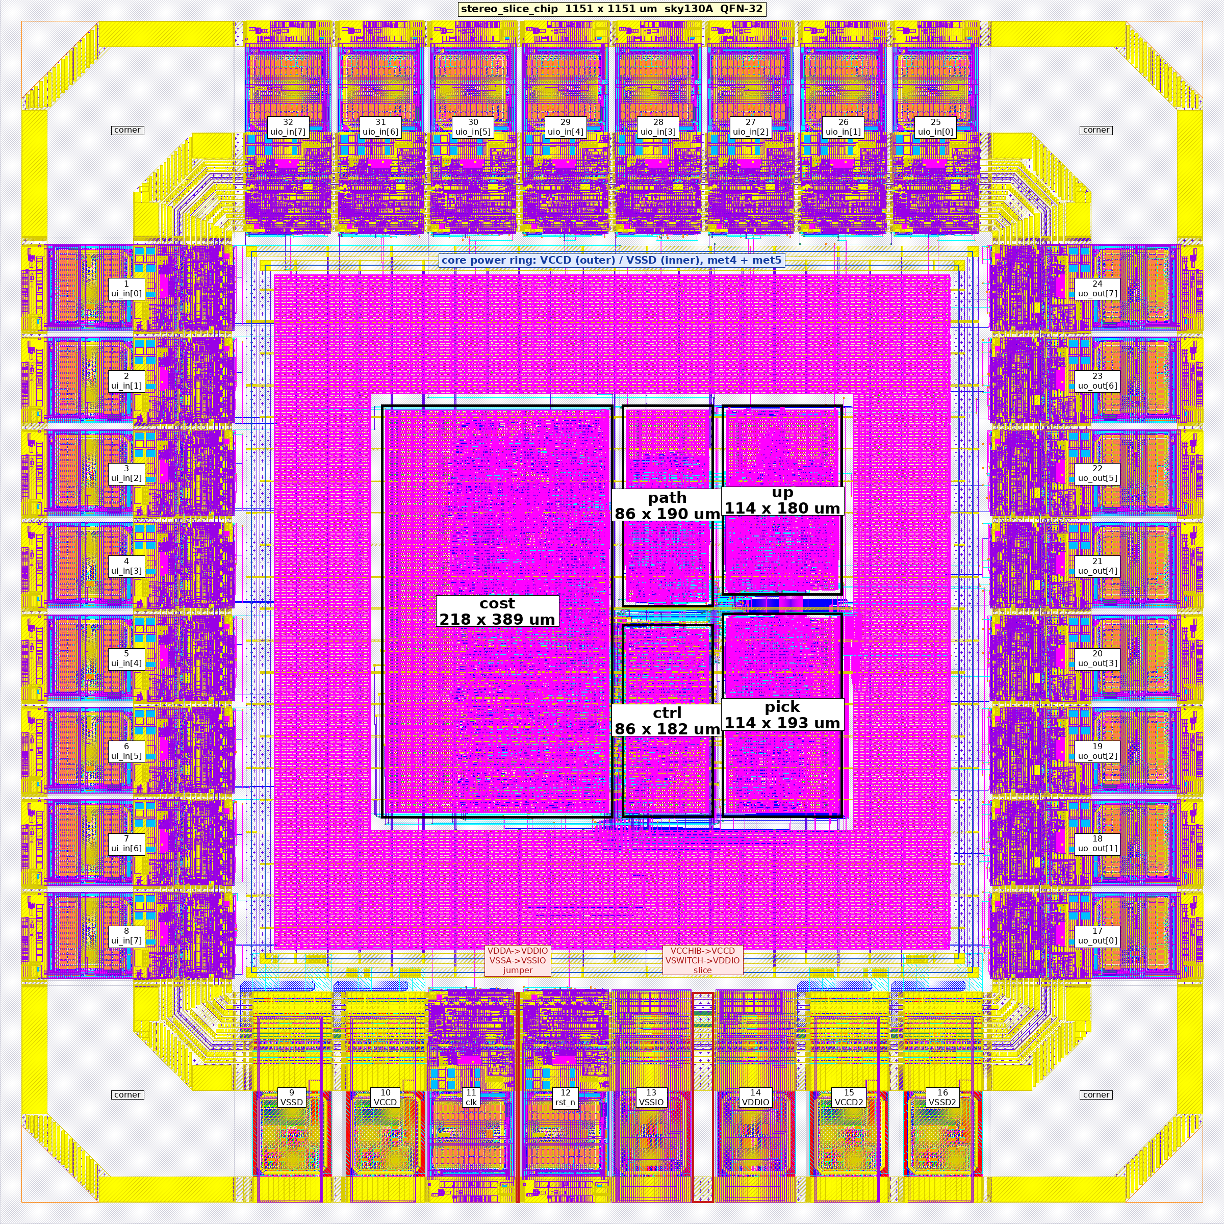
GAMBAR 1A: DESAIN TATA LETAK BERKETERANGAN
(ANNOTATED LAYOUT)

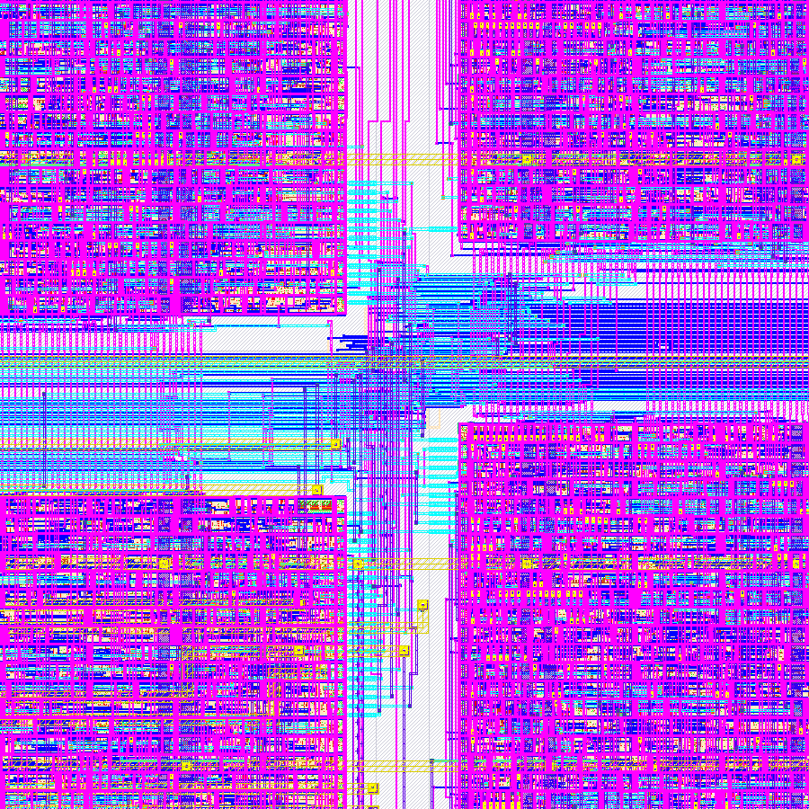
GAMBAR 1B: PERBESARAN 120 × 120 µm
(LAYOUT ZOOM, PERSIMPANGAN KANAL)
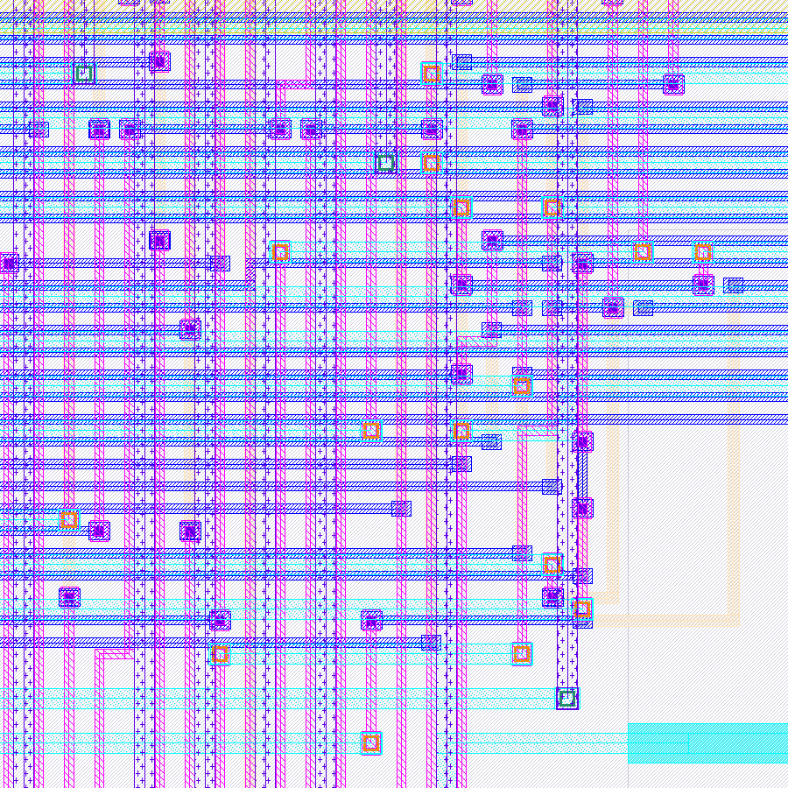
GAMBAR 1C: PERBESARAN 12 × 12 µm
(LAYOUT ZOOM, SEL STANDAR)

Gambar lainnya dapat berupa
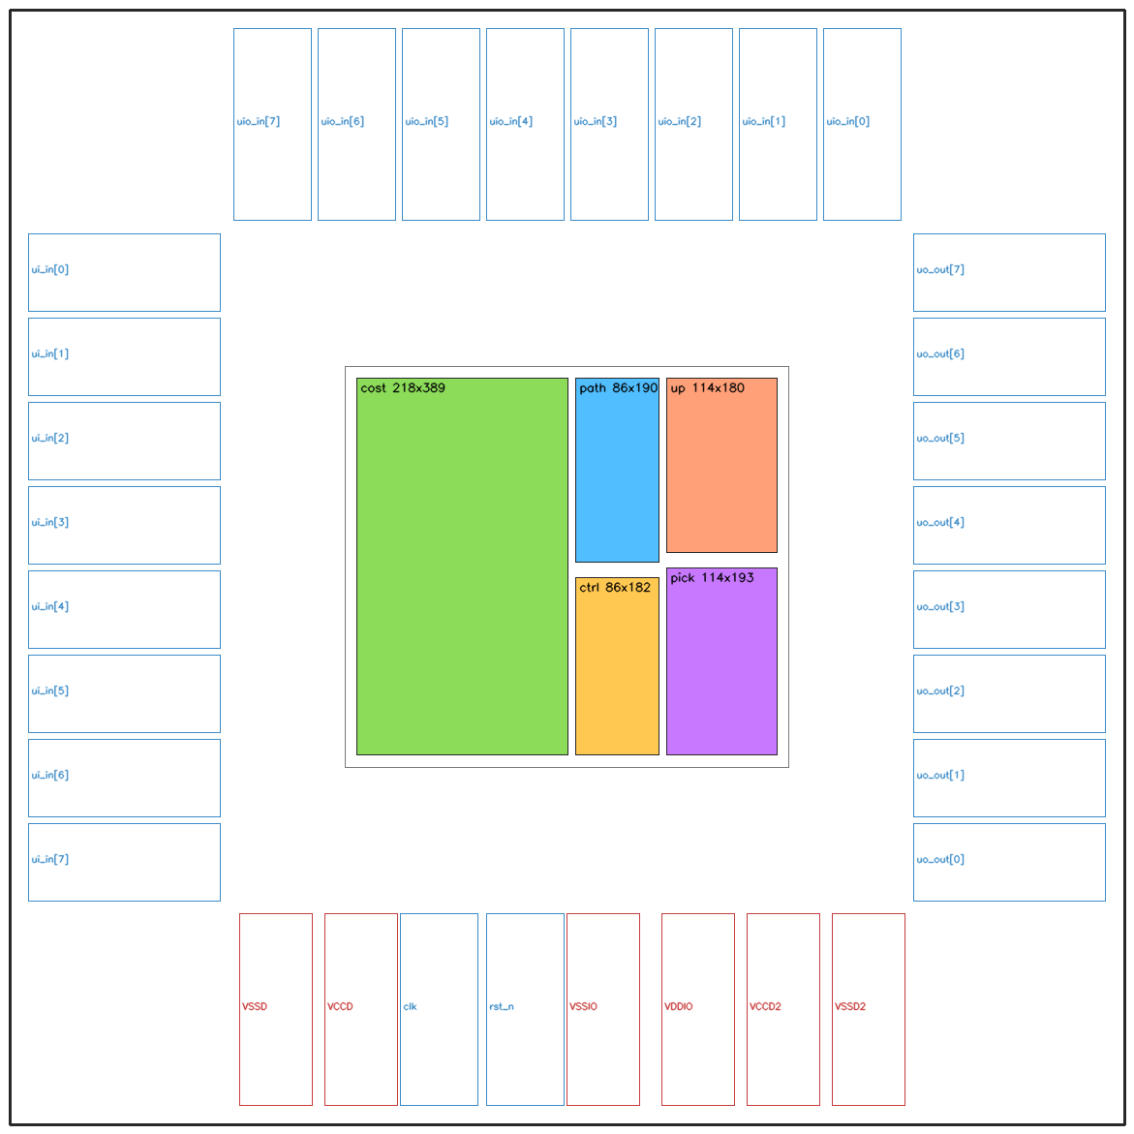
GAMBAR 2: FLOORPLAN

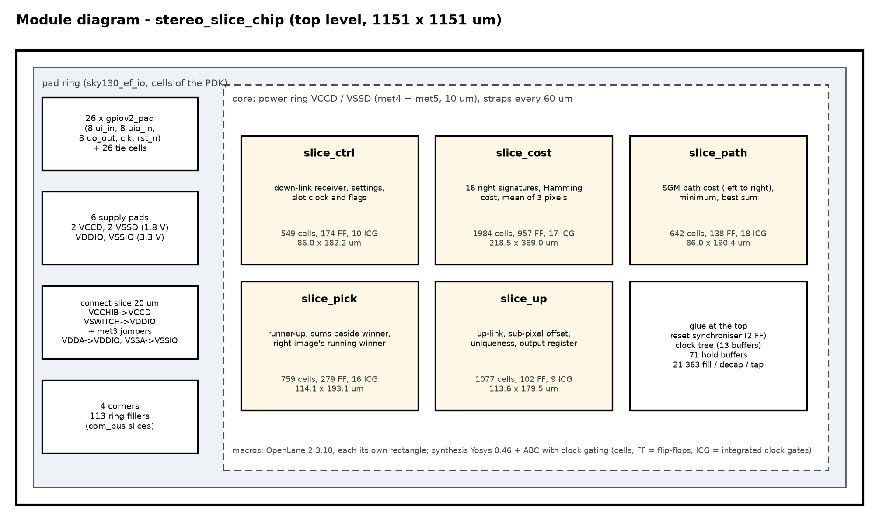
GAMBAR 3: DIAGRAM BLOK
(BLOCK DIAGRAM/MODUL LEVEL)

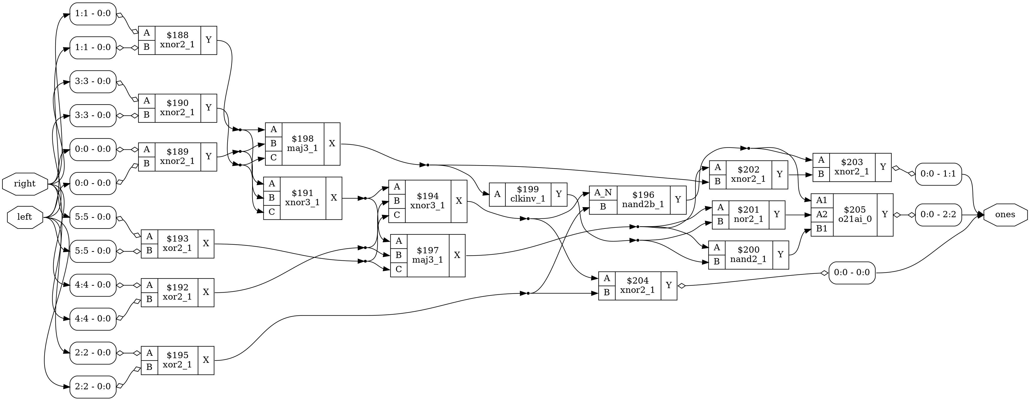
GAMBAR 4: DESAIN LOGIKA
(LOGIC DESIGN/GATE LEVEL)
Inti biaya Hamming slice_cost: 18 sel sky130_fd_sc_hd, 166,4 µm²

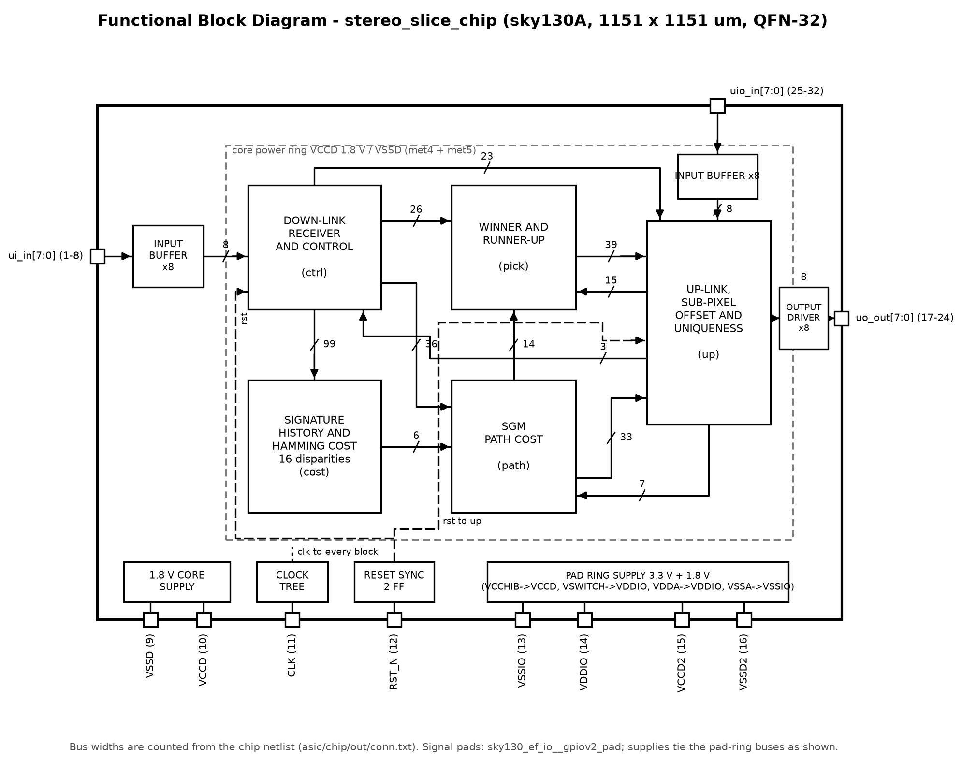
GAMBAR 5: DIAGRAM BLOK FUNGSIONAL
(FUNCTIONAL BLOCK DIAGRAM)

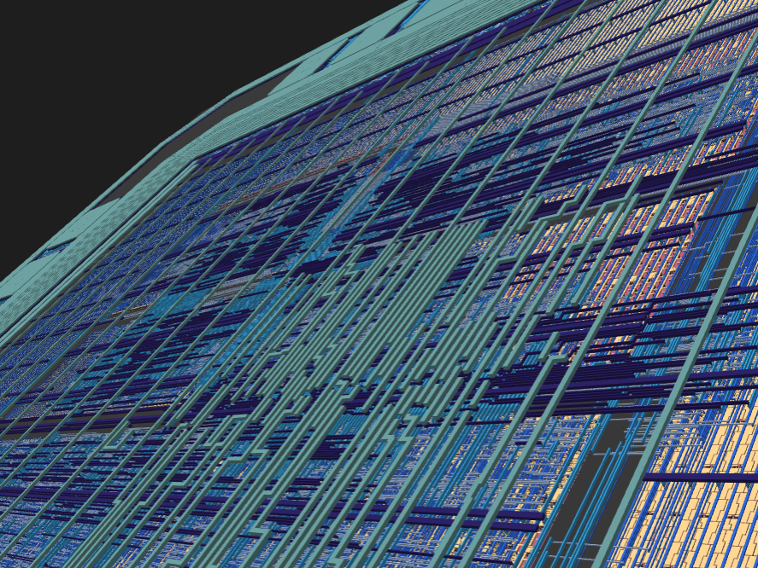
GAMBAR 6: MODEL TIGA DIMENSI
(3D LAYOUT VIEW)
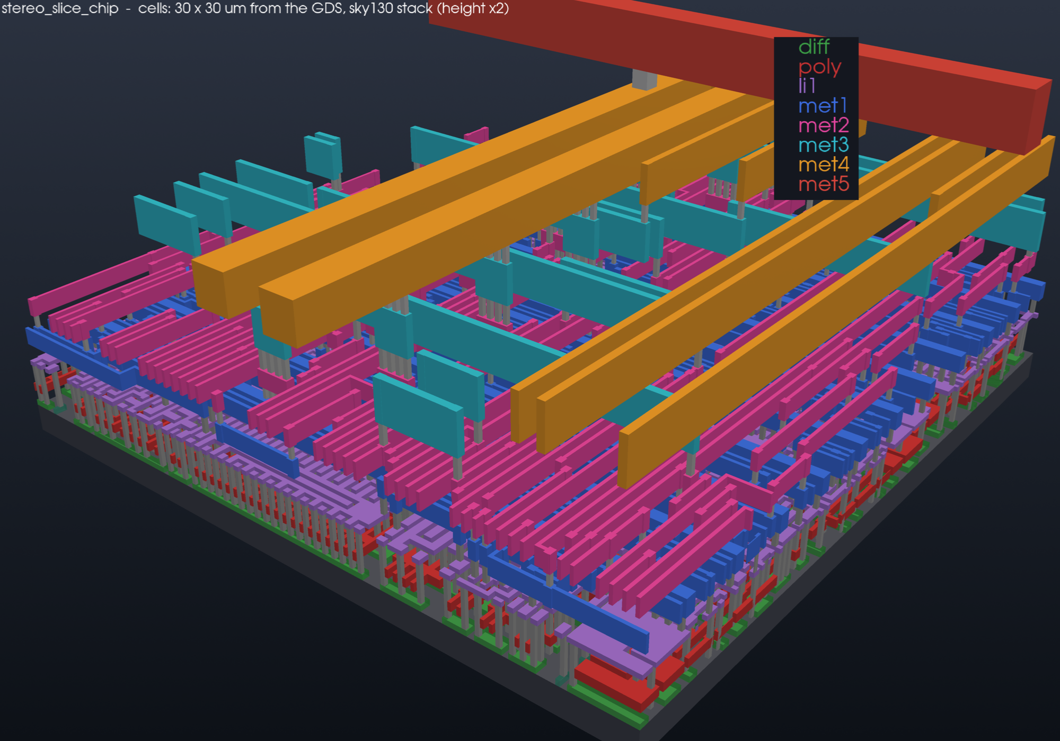
GAMBAR 7: TOPOLOGI ROUTING li1–met5
(3D INTERCONNECT, 30 × 30 µm)

